EXPERIMENT : 22
from google.colab import files
uploaded = files.upload()
import cv2
import numpy as np
import matplotlib.pyplot as plt
filename = list(uploaded.keys())[0]
image = cv2.imread(filename, 0)
print("Image uploaded successfully:", filename)
kernel = np.ones((9, 9), np.uint8)
closing = cv2.morphologyEx(
image,
cv2.MORPH_CLOSE,
kernel
)
plt.imshow(image, cmap="gray")
plt.title("Original Image with Small Gaps")
plt.axis("off")
plt.show()
plt.imshow(closing, cmap="gray")
plt.title("Closing Output")
plt.axis("off")
plt.show()
plt.figure(figsize=(10, 4))
plt.subplot(1, 2, 1)
plt.imshow(image, cmap="gray")
plt.title("Original Image")
plt.axis("off")
plt.subplot(1, 2, 2)
plt.imshow(closing, cmap="gray")
plt.title("Closing Output")
plt.axis("off")
plt.show()
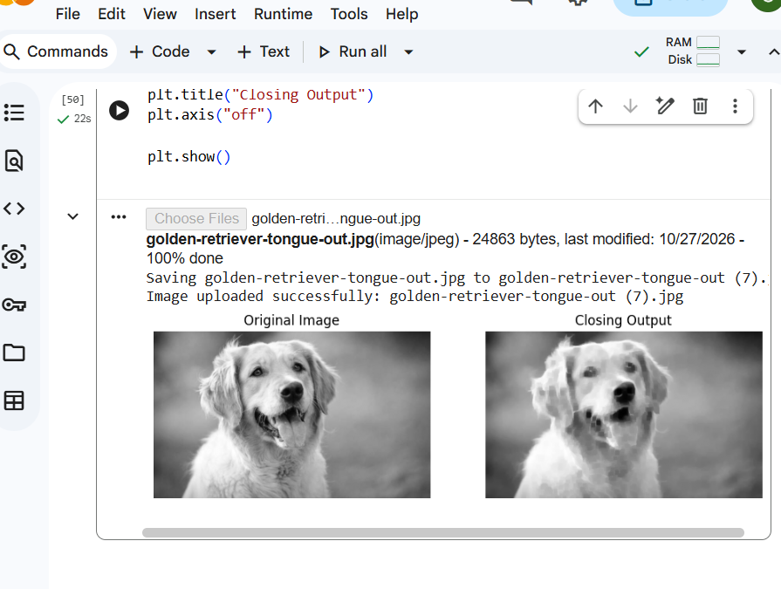

EXPERIMENT : 23

From google.colab import files
uploaded = files.upload()

import cv2
import numpy as np
import matplotlib.pyplot as plt

# Read the uploaded image
filename = list(uploaded.keys())[0]
image = cv2.imread(filename, 0)

print("Image uploaded successfully:", filename)

# Create kernel
kernel = np.ones((15, 15), np.uint8)

# Apply Top-Hat operation
tophat = cv2.morphologyEx(
image,
cv2.MORPH_TOPHAT,
kernel
)

# Display original and Top-Hat output
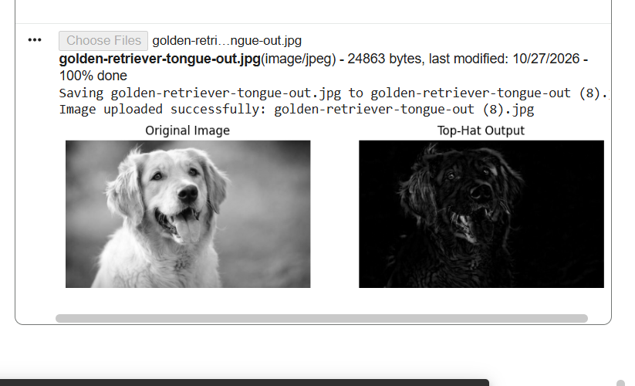

EXPERIMENT : 24

from google.colab import files
uploaded = files.upload()

import cv2
import numpy as np
import matplotlib.pyplot as plt

# Read the uploaded image
filename = list(uploaded.keys())[0]
image = cv2.imread(filename, 0)

print("Image uploaded successfully:", filename)

# Create kernel
kernel = np.ones((15, 15), np.uint8)

# Apply Black-Hat operation
blackhat = cv2.morphologyEx(
image,
cv2.MORPH_BLACKHAT,
kernel
)

# Display original and Black-Hat output
plt.figure(figsize=(10, 4))

plt.subplot(1, 2, 1)
plt.imshow(image, cmap="gray")
plt.title("Original Image")
plt.axis("off")

plt.subplot(1, 2, 2)
plt.imshow(blackhat, cmap="gray")
plt.title("Black-Hat Output")
plt.axis("off")

plt.show()

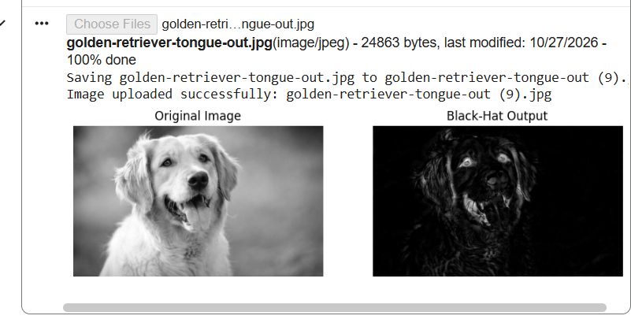

EXPERIMENT : 25
from google.colab import files
uploaded = files.upload()

import cv2
import numpy as np
import matplotlib.pyplot as plt

from tensorflow.keras.applications import MobileNetV2
from tensorflow.keras.applications.mobilenet_v2 import (
preprocess_input, decode_predictions
)

# Read the uploaded image
filename = list(uploaded.keys())[0]
image = cv2.imread(filename)

if image is None:
raise ValueError("Image not found")

print("Image uploaded successfully:", filename)

# Display input image
plt.imshow(cv2.cvtColor(image, cv2.COLOR_BGR2RGB))
plt.title("Input Image")
plt.axis("off")
plt.show()

# Load pretrained model
model = MobileNetV2(weights="imagenet")

# Prepare image
img = cv2.resize(image, (224, 224))
img = cv2.cvtColor(img, cv2.COLOR_BGR2RGB)
img = np.expand_dims(img, axis=0)
img = preprocess_input(img)

# Predict object
predictions = model.predict(img)
results = decode_predictions(predictions, top=5)[0]

print("\nTop 5 Predictions:")
for _, label, confidence in results:
print(label, ":", round(confidence * 100, 2), "%")

# Display best prediction
best_label = results[0][1]
confidence = results[0][2] * 100

plt.imshow(cv2.cvtColor(image, cv2.COLOR_BGR2RGB))
plt.title(f"Detected: {best_label} ({confidence:.2f}%)")
plt.axis("off")
plt.show()

